Daniel Diamont – dd28977

Robert Noe

EE445L

Lab 3 Report

1. **Objectives**

**Requirements document**

1. Overview

1.1. Objectives: Why are we doing this project? What is the purpose?

The objectives of this project are to design, build and test an alarm clock. Educationally, students are learning how to design and test modular software and how to perform switch/keypad input in the background.

1.2. Process: How will the project be developed?

The project will be developed using the TM4C123 board. There will be switches or a keypad. The system will be built on a solderless breadboard and run on the usual USB power. The system will use the on-board switches as user inputs and will use the on-board LEDs to display a heartbeat. The speaker will be external. There will be four hardware/software modules: switch/keypad input, time management, LCD graphics, and sound output. The process will be to design and test each module independently from the other modules. After each module is tested, the system will be built and tested.

1.3. Roles and Responsibilities: Who will do what? Who are the clients?

EE445L students are the engineers and the TA is the client. Students are expected to modify this document to clarify exactly what they plan to build. Students are allowed to divide responsibilities of the project however they wish, but, at the time of demonstration, both students are expected to understand all aspects of the design.

Action Items:

* Requirements Document – Robert Noe and Daniel Diamont
* PCB Artist – Robert Noe
* Hardware Setup – Robert Noe and Daniel Diamont
* Sound Interface Software – Robert Noe
* Timer Management Software – Daniel Diamont
* LCD Graphics Software – Daniel Diamont
* Switch/Keypad Input Software – Robert Noe
* Main Test Program Software – Daniel Diamont
* Main Program – Robert Noe and Daniel Diamont

1.4. Interactions with Existing Systems: How will it fit in?

The system will use the TM4C123 board, a ST7735 color LCD, a solderless breadboard, and be powered using the USB cable. The system will interface with an external 32 Ohm speaker.

1.5. Terminology: Define terms used in the document.

* Power budget – Estimation of time that a battery powered embedded system can run; energy divided by the average current draw of the system.
* Device driver – A collection of software routines that perform I/O functions
* Critical section – Locations within a software module, which if an interrupt were to occur at one of these locations, then an error could occur (e.g. data lost, corrupted data, program crash, etc.) Same as vulnerable window.
* Latency – Response time of the computer to external events. For example, the time between an input becoming available and the time the input is read by the computer. Latency for I/O devices is the response time of the external I/O device hardware to a software command.
* Time jitter – The difference between the largest and smaller time difference in a software dump that keeps track of the time it takes to execute a specified action.
* Modular programming – A style of software development that divides the software problem into distinct and independent modules.

1.6. Security: How will intellectual property be managed?

The system may include software from TivaWare and from the book. No software written for this project may be transmitted, viewed, or communicated with any other EE445L student past, present, or future (other than the lab partner of course). It is the responsibility of the team to keep its EE445L lab solutions secure.

2. Function Description

2.1. Functionality: What will the system do precisely?

The clock must be able to perform five functions. 1) It will display hours and minutes in both graphical and numeric forms on the LCD. The graphical output will include the 12 numbers around a circle, the hour hand, and the minute hand. The numerical output will be easy to read. 2) It will allow the operator to set the current time using switches or a keypad. 3) It will allow the operator to set the alarm time including enabling/disabling alarms. 4) It will make a sound at the alarm time. 5) It will allow the operator to stop the sound. An LED heartbeat will show when the system is running. 6) The system will allow the operator to select an alarm in AM or PM format. 7) The system will allow the operator to switch the color scheme of the alarm clock upon the push of a button.

2.2. Scope: List the phases and what will be delivered in each phase.

Phase 1 is the preparation; phase 2 is the demonstration; and phase 3 is the lab report. Details can be found in the lab manual.

2.3. Prototypes: How will intermediate progress be demonstrated?

A prototype system running on the TM4C123 board, ST7735 color LCD, and solderless breadboard, and will be demonstrated. Progress will be judged by the preparation, demonstration and lab report.

2.4. Performance: Define the measures and describe how they will be determined.

The system will be judged by three qualitative measures. First, the software modules must be easy to understand and well-organized. Second, the analog clock display should be beautiful and effective in telling time. Third, the operation of setting the time and alarm should be simple and intuitive. The system should not have critical sections. All shared global variables must be identified with documentation that a critical section does not exist. Backward jumps in the ISR should be avoided if possible. The interrupt service routine used to maintain time must complete in as short a time as possible. This means all LCD I/O occurs in the main program. The average current on the +5V power will be measured with and without the alarm sounding.

2.5. Usability: Describe the interfaces. Be quantitative if possible.

There will be four switch inputs (SW1 and SW2 on the Launchpad) and two external switches. In the main menu, the switches can be used to activate 1) set time; 2) set alarm; 3) turn on/off alarm; and 4) change display mode. The user should be able to set the time (hours, minutes) and be able to set the alarm (hour, minute) using the four switch inputs. After some amount of inactivity the system reverts to the main menu. The user should be able to control some aspects of the display configuring the look and feel of the device. Specifically, the user will be able to update the foreground and background color of the analog clock. The switches MUST be debounced, so only one action occurs when the operator touches a switch once.

The LCD display shows the time using graphical display typical of a standard on the wall clock. The 12 numbers, the minute hand, and the hour hand are large and easy to see. The clock can also display the time in numeric mode using numbers.

The alarm sound can be a simple square wave. The sound amplitude will be just loud enough for the TA to hear when within 3 feet.

2.6. Safety: Explain any safety requirements and how they will be measured.

The alarm sound will be VERY quiet to respect other people in the room during testing. Connecting or disconnecting wires on the protoboard while power is applied may damage the board.

3. Deliverables

3.1. Reports: How will the system be described?

A lab report described below is due by the due date listed in the syllabus. This report includes the final requirements document.

3.2. Audits: How will the clients evaluate progress?

The preparation is due at the beginning of the lab period on the date listed in the syllabus.

3.3. Outcomes: What are the deliverables? How do we know when it is done?

There are three deliverables: preparation, demonstration, and report.

1. **Hardware Design (PCB Artist)**

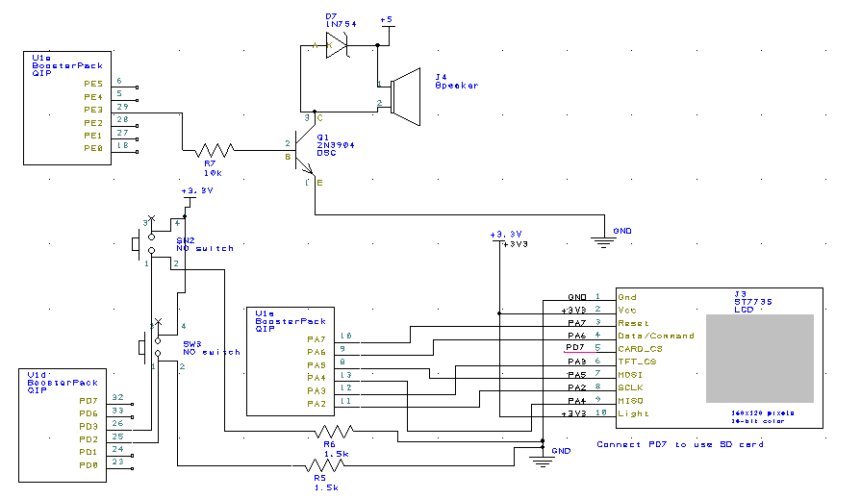

1. **Software Design**
   1. The call graphs and data flow graphs are equal to those supplied in the lab description.

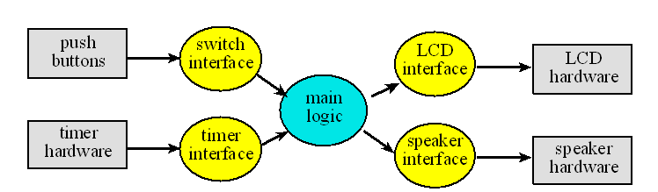

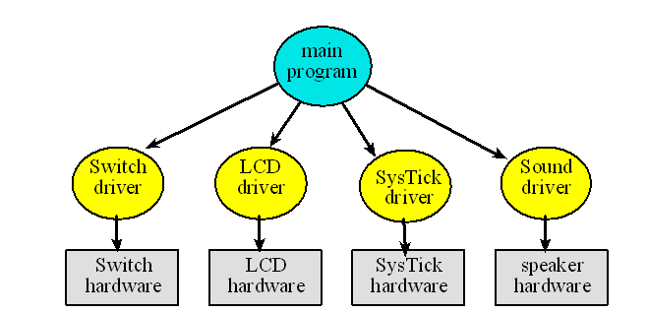

* 1. Please see the attached .h and .c files in this .zip file.
     1. ADCSWTrigger.h/.c
     2. Clock.h/.c
     3. Fixed.h/.c
     4. LUT_generator.py
     5. Main.c
     6. Sound.h/.c
     7. ST7735.h/.c
     8. Switches.h/.c
     9. Timer.h/.cs

1. **Measurement Data**
   1. **5V and 3.3V power supply**

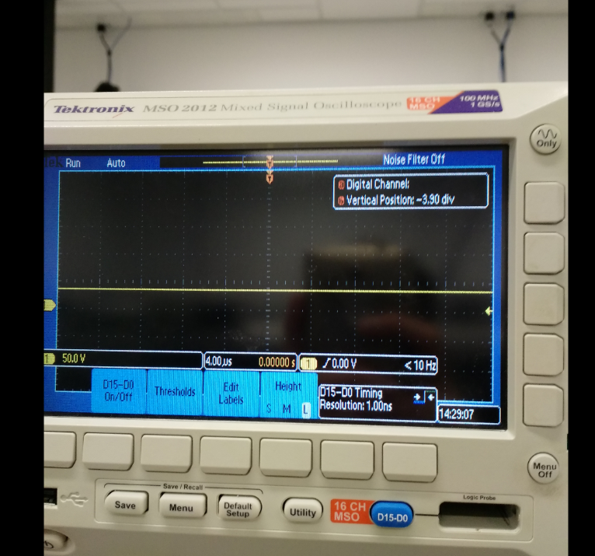

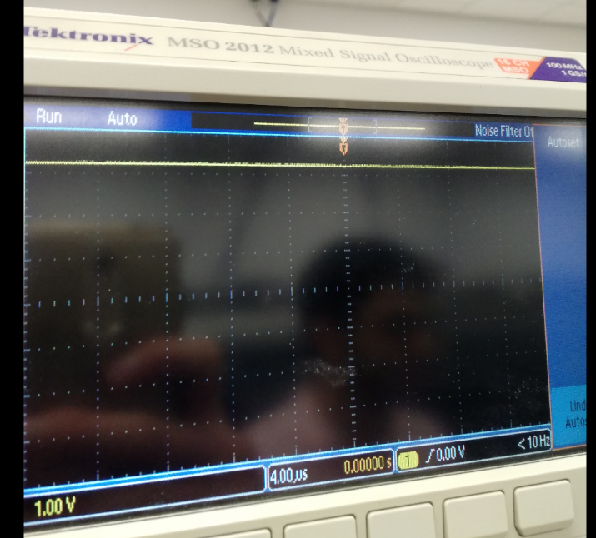

* 1. **Speaker voltage**

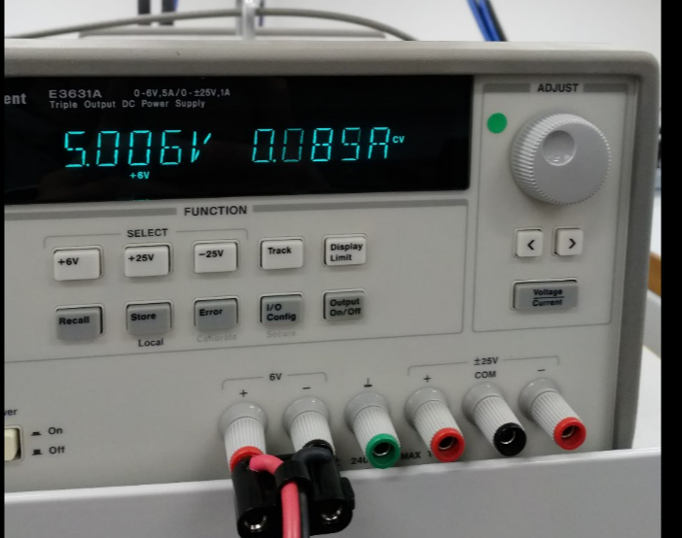

* 1. **Current measurements at 5V and 3.3V**

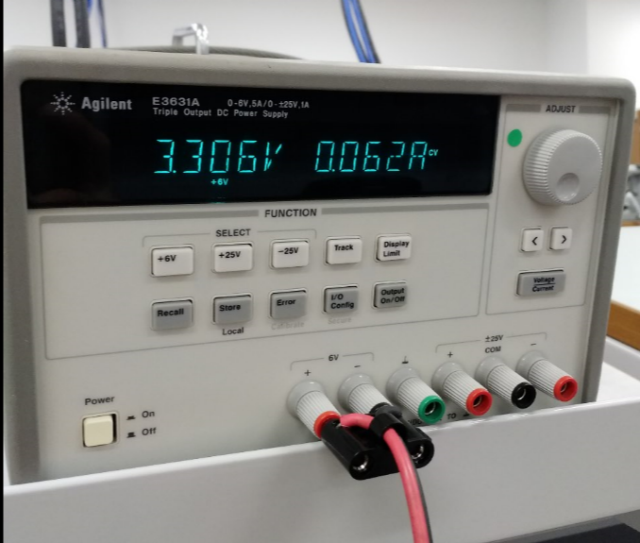

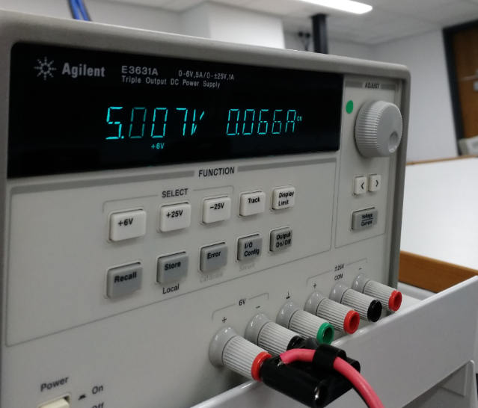

1. **Analysis and Discussion**
2. **Combining interrupts and setting interrupts at appropriate priorities will eliminate critical sections.**
3. **It takes less than 100ms.**
4. **The extra time that it takes to update the LCD would throw of the timing of the clock. It will take far more than one second to increment the time by one second.**
5. **The clock was redrawn for each output. To flicker less, a line with the same color as the background should be drawn in the place of the previous line before redrawing the new one.**
6. **Power could have been saved by redrawing only the hands of the clock and not the entire screen, used timed interrupts to create delays instead of loops, and replace if statements with bit manipulation.**